
I. JADEED

THE CROSS
in the Gospel
and the Koran

All rights reserved
THE GOOD WAY • P.O.BOX 66
CH-8486 RIKON-SWITZERLAND
CONTENTS
INTRODUCTION:
THE CRUCIFIXION OF CHRIST AND
ITS INFLUENCE ON ISLAM 5
I. THE CROSS IN THE GOSPEL
AND IN THE KORAN. 9
II. OUR PROOFS OF THE
CRUCIFIXION OF CHRIST 20
- THE PROPHECIES ' 20
- THE STATEMENTS OF CHRIST 26
- THE TESTIMONY OF THE APOSTLES 28
- THE SIGNS WHICH ACCOMPANIED
THE DEATH OF CHRIST 29-
- THE RESURRECTION OF CHRIST 30
- THE TESTIMONY OF HISTORY 32
- THE TESTIMONY OF PILATE,
THE ROMAN GOVERNOR 33
- THE SYMBOL OF THE CROSS 33
- THE TESTIMONY OF TIME AND
CHRISTIAN CONTINUANCE 34
10. THE TESTIMONY OF THE
JEWISH TALMUD 34

III. WHY WAS CHRIST
CRUCIFIED?
- THE NEED OF SALVATION
- THE PROOF OF REASON
- ATONEMENT MEETS THE
DEMANDS OF LAW
- ATONEMENT MEETS MAN'S
MORAL NEED
- GOD'S PLAN FOR ATONEMENT
36
36
37
37
38
39


INTRODUKTION

THE CRUCIFIXION OF CHRIST AND
ITS INFLUENCE ON ISLAM
This subject, more than any other, arouses
controversy among Muslims. Though the Koran
mentions the death of Christ before His ascension to
heaven, Islamic scholars disagree over the inter-
pretation of the word 'inni mutawaffeeka' (translated
'gathering thee') in verse 55 of Surat al Imran. Some
say the word does not indicate 'death', while others
affirm that Christ did actually die. There are many
versions of this, ascribed to eminent muslim schools,
on interpretations of scholars such as Al Tabari and
Al Zamkhashri, and others.
Some say the word means:
- Sleep.. AI Muthanna relates 'I was told by
Ishaq (as reported to him by Abd Allah Ibn Jaafar
and Al Rabia) that 'inni mutawaffeeka' means a
death of sleep, and God raised Him in His sleep'.
- Fulfilment, or completion - by Ali Ibn Suhail
and Domra Ibn Rabia and Ibn Shuthab, and Matar
al Waraq, who say it means 'I, God, gather you from
the world, but not by death'.

- Grasping, or 'take possesion of - by Yunis who
says 'Ibn Wahab and Ibn Zeid have told us that 'inni
mutawaffeeka' signifies 'I grasp - take possesion -
of you... He has not died and will not die until He
kills the Anti-Christ. Then He will die'.
- Abu Jaafar al Tabari, ascribing it to tradition
from Muhammed said "Fsa (Jesus), the Son of Mary,
will descend and kill the Anti-Christ, then remain on
earth for a while (time not stated) and then He will die
and Muslims will bless Him."
The group which maintains that the word means
real death also has many interpretations of the story.
- AI Muthanna says, quoting Abd Allah Ibn
Salih and Muawiheh, and Ali Ibn Abbas, that 'inni
mutawaffeeka' means 'I cause you to die'.
- From Ibn Hamid, as told him by Salma and Ibn
Ishaq, and Wahab Ibn Munabbih, 'God caused' I'sa,
Son of Mary, to die three hours and then raised Him'.
(Jamia al bayan 3.289-292).
The interpretation of Al Imam Al Razi, from
which we quote the following verses says when God
said, "O Jesus! Lo! I am gathering thee and causing
thee to ascend unto Me" that God was specifically
exalting him. Firstly 'inni mutawaffeeka' - by raising
Him, and another verse ascribed to Jesus says,
"When Thou tookest Me, Thou wast a Watcher over
them," that is, guarding Him.
Commentators differ over these two verses in two
ways. Some accept the verses literally and others see
hidden meanings in them.
The first say 'mutawaffeeka' means 'your life is
fulfilled, so I (God) will take you, and not permit
them (that is - the Jews) to kill you, but I will raise
you to heaven and appoint you among my angels,
and I will protect you so that they will not be able to
kill you.'
The second say 'mutawaffeeka' means 'I cause you
to die'. According to Ibn Abbas and Hama Ibn Ishaq
it means, 'His enemies, the Jews, were not permitted
to kill Him, so God honoured Him by raising Him to
heaven.' These also differed in three points:
- Wahab said, 'He was dead three hours and
then was raised.'
- Muhammed Ibn Ishaq said, 'He was dead
seven hours, then God raised Him to life and
took Him to heaven.'
- AI Rabia Ibn Uns said that God caused Him
to die when He raised Him to heaven. God
says, "The Lord 'gathers' souls at death, and
they do not die in their sleep."
So, because of these differences of opinion among
Muslim experts, and their different interpretations
of a verse in the Koran about the last moments in the
life of Christ, any honest seeker after the truth, must
turn to the record of the Gospel, which needs no
interpretation. There is no contradiction in it, with
regard to the death of Christ, and His resurrection
and ascension.
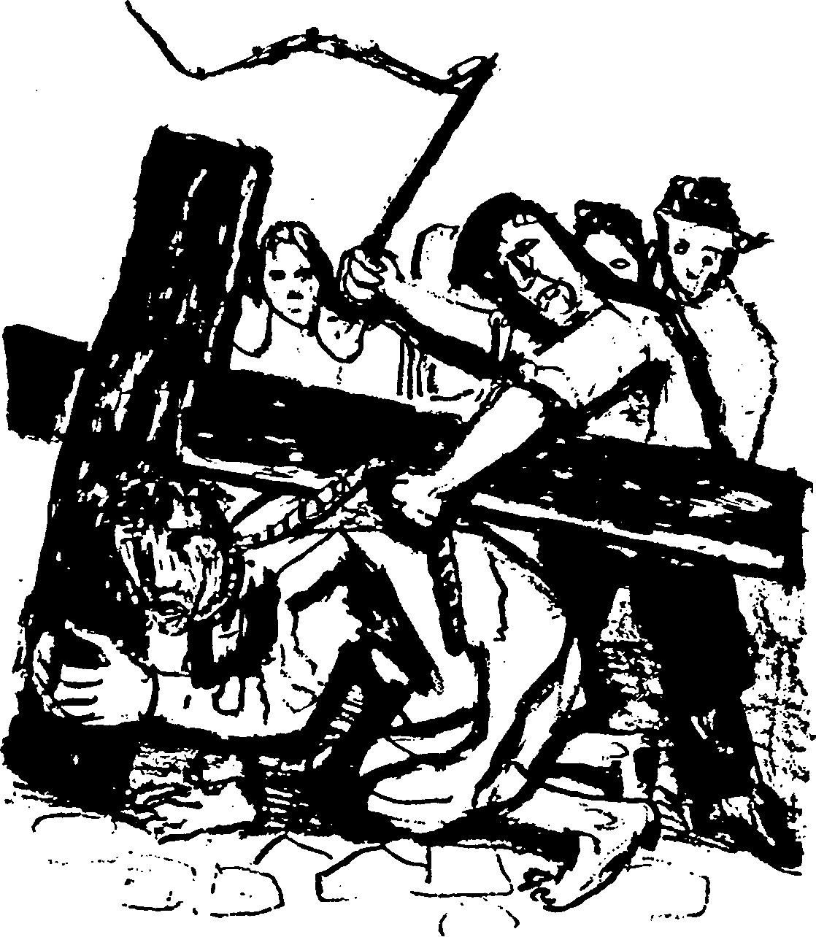
THE CROSS IN THE GOSPEL AND
IN THE KORAN
In chapter one of his first letter to the Corinthians,
verses 22 to 24, Paul, the apostle, said, "For the Jews
demand signs, and Greeks seek wisdom, but we
preach Christ crucified, a stumbling block to Jews,
and folly to Gentiles, but to those who are called,
both Jews and Greeks, Christ the power of God, and
the wisdom of God." In the second chapter, verses I
to 2, he said, "When I came to you, brethren, I did not
come proclaiming to you the testimony of God in
lofty words of wisdom. For I decided to know
nothing among you except Jesus Christ and Him
crucified."
If we consider the words of the apostles generally
we see that the Gospel which they preached from the
dawn of Christianity and which people received and
accepted and by which they were saved, was the joyful
news which Paul summarized in these words in 1
Corinthians 15:1-4: "Now I would remind you,
brethren, in what terms I preached to you the Gospel,
which you received, in which you stand, by which you
are saved, if you hold it fast - unless you believed in
vain. For I delivered to you as of first importance,
what I also received, that Christ died for our sins,
according to the Scriptures, that He was buried, that
He was raised on the third day, in accordance with the
Scriptures."
Even so, with the passing of some five hundred
years after Paul and the spreading of the Gospel in all
the world, there were those who objected to this truth
saying to the Christians, "You are mistaken in your
religion". Maybe these objectors took their ideas from
heretics - Jews converted to Christianity, whose
fathers were neighbours to those who believed that
Christ would (did) not die. We are very indebted to
John, one of the writers of the Gospel, who mentions,
this matter when he recorded for us the saying of the
Pharisees in their dispute with Christ, in John 12:34,
"The crowd answered Him, 'We have heard from the
Law that the Christ remains for ever. How can you
say that the Son of Man must be lifted up? Who is this
Son of Man?'"
Historians mention that this heresy was widespread
among the Christians of the Arabian Peninsula,
saying that Christ was able to transform Himself from
one image (form) to another, and when His enemies
came to arrest Him He cast His likeness on to another
man, who was crucified instead of Him, but Christ
was lifted up to the One who sent Him, scorning His
enemies.
The passage in the Koran about the last days of
Christ is in agreement with this story and opposed to
the Jewish version. It says, Surat an Nisa 157, 158
10
"Their saying, (that is the Jews) 'We slew the
Messiah, Jesus the Son of Mary, Allah's Messenger',
they slew Him not, nor crucified Him, but it
appeared so unto them, and lo! Those who disagree
concerning it, are in doubt thereof, they have no
knowledge thereof, save pursuit of a conjecture, they
slew Him not for certain, but Allah took Him up to
Himself."
Clearly we understand from the version of the
heretics who clung to Christianity, that the Cross, in
their estimation, was not an historical event, or a
doctrine of redemption, but a symbol or a sign, as the
star which guided the Magi to the cradle of the Child
in Bethlehem, or as the appearance of a dove in
which the Holy Spirit appeared, coming to Christ at
His baptism in the Jordan. But the heavy cross on
which Christ was hanged, which is the altar of
redemption, where the Lamb of God was sacrificed to
take away the sin of the world, was of no importance
to them! They rejected the truth which Paul
proclaimed to the nations in Galatians 3:13 and 14,
"Christ redeemed us from the curse of the Law,
having become a curse for us; for it is written 'Cursed
be everyone who hangs on a tree, that in Christ Jesus
the blessing of Abraham might come upon the
Gentiles, that we might receive the promise of the
Spirit through faith.'"
Perhaps the strängest objection to the cross is
found in the counterfeit Gospel attributed to John
11
but written by the heretics. There is no doubt Muslims
inherited this aversion to the cross from those heretics
who were scattered about in Arabia, which is the
cradle of Islam. It is regrettable that Muslim
theologians disagree on the matter of how another
took the place of Christ, and many stories have arisen
about it. One is that when the Jews determined to kill
Christ, God took Him to heaven. Their leaders feared
a rising of the people against themselves, and took and
killed a man crucifying him, and deceived the people
saying he was Christ (I'sa). Another says that God
cast Christ's likeness on to another man, who died
instead of Him.
This story has many versions:
- A Jew named Judas entered a house where
Christ was, with the purpose of arresting Him, but did
not find Him. God caused the likeness of Christ (I'sa)
to be on him, and when he came out of the house
people thought he was I'sa, and took him and
crucified him.
- The Jews, when they arrested I'sa, set over Him
a watchman, but I'sa was taken up to God by a
miracle and God caused I'sa's likeness to rest on the
watchman, whom they took and crucified, while he
cried out "I am not I'sa".
- One of Jesus' (I'sa's) friends was promised
Paradise, and volunteered to die instead of Him.
12
God caused him to resemble I'sa and he was taken
and crucified but I'sa was taken up to heaven.
4) One of I'sa's followers betrayed Him, (that is,
Judas), and came to the Jews to guide them to Him,
and went with them to take Him. God caused him to
appear like I'sa and he was taken and crucified.
Only a few of the commentators of the Koran
agree upon this story. Al Jalalan in his interpretation
of the Koranic phrase "it appeared so unto them"
(Shubbiha lahum) says that Allah caused the likeness
of I'sa to be upon the dead man and they thought he
was I'sa, and they killed and crucified him. The phrase
"those who disagree and are in doubt about Him"
(that is, about I'sa, regarding His death) - means that
some of them, when they saw the dead man, said "The
face is the face of I'sa, but the body is not His body".
Others said "It is He". (Commentary of Al Jalalan,
page 135).
Al Baidawi said "It is related that a group of Jews
captured I'sa and his mother, and He cursed them,
and they were changed into apes and pigs! The Jews
met together to kill Him but God told Him He would
take Him to heaven. He said to His friends, 'Who is
ready to take my likeness upon him and be killed and
crucified and enter Paradise?' One of them responded
and God cast the likeness of I'sa upon him and he was
killed and crucified."
13
AI Zamkhashri said "The words 'it appeared so unto
them' mean they imagined it to be so or they pre-
sumed that they killed and crucified Him - so He is
dead and not alive. But He is alive because God took
Him to Himself.
There is no doubt that this variety of versions
resulted from the lack of clear wording in the Koran
with regard to the last days of Christ's human life on
earth. This disparity opened the door to many
differences and opposing opinions. It was inevitable
that a scrupulous scholar such as the Imam Fakhr ed
Din ar Razi should refute this story absolutely. In his
comment on verse 55 of Surat al Imran "Oh Fsa Son
of Mary, lo! I am gathering Thee unto Me and causing
Thee to ascend to Me," he explained the matter of the
transfer of Christ's likeness to another man in a
variety of ways:
- If it is permissible to assert that God casts the
resemblance of one person on to another, then the
door is open to calumny and in time to subtle
reasoning and in the end invalidates prophecies.
- God supported Him (I'sa) with His Holy Spirit.
Was He in this case not able to do so? He (I'sa) was
able to raise the dead, and so was He not able to
protect Himself?
- God was able to rescue Him by raising Him to
heaven, so what use was it to cause another to bear
His likeness?
14
- By so doing - that is by causing another to
resemble Him - they were made to believe that this
other was I'sa, although he was not. This was a
deception and not in keeping with the wisdom of
God.
- The majority of Christians from East to West,
with their intense love for Christ and extreme zeal for
His cause, witnessed to His being crucified. There-
fore, if we deny this, we discredit the historicity
(chronology) of events and thus we discredit the
prophecy of Mohammed and I'sa and the rest of the
prophets.
- The logical (normal) thing would be, that the
"other man" would be able to defend himself and say
he was not I'sa and that is what he would have done.
As he did not do so, we understand the matter was
not as reported. If the sayings of the Koran do
repudiate the crucifixion of Christ, they certainly do
not repudiate His death, before He was taken to
heaven. When we consider the close of Christ's life as
seen (depicted) in the Koran, we find three texts which
confirm His death, and two which state that He was
killed.
1. Surat al Mariam 33 - "Peace on me the day I was
born, and the day I die, and the day I shall be raised
alive." In this verse is a clear confession that Christ
became incarnate, and died and was raised from the
15
dead, in the form of a prophecy and based on a
miracle. It agrees with the text of the Gospel in spirit
and word.
- Surat al Imran 55 - "When God said 'Oh Jesus,
Son of Mary, lo! I am gathering thee and causing thee
to ascend to me and I am cleansing thee of those who
disbelieve, and I am setting those who follow thee
above those who disbelieve until the day of Resurrec-
tion.'"
- Surat al Mai-i'dat (The Table) 116,117 - "When
Allah saith 'Oh Jesus, Son of Mary, did thou not say
unto mankind, "Take me and my mother for two gods
beside Allah?" he said, 'Be glorified... I spake unto
them only that which Thou commandest me... and
when Thou tookest me, Thou wast the watcher over
them.'"
- Surat al Baqara (The Cow) 87 - "And verily we
gave unto Moses the Scripture, and we caused a train
of messengers to follow after him, and we gave unto
Jesus, Son of Mary, clear proofs, and we supported
him with the Holy Spirit. It is ever so, that when there
cometh unto you a messenger (from Allah) with that
which you desire not, you grow arrogant, and some
you disbelieve, and some you slay." The word "slay"
here is not unclear and can only be translated as
"killing". If the Koran does not mention how the
killing of Christ took place, the Gospel is the original
and only source on this subject.
16
5. Surat al Imran 183... "They say, that is the Jews,
'Lo, God hath charged us that we believe not in any
messenger until he bring us an offering which fire,
from heaven, shall devour'. Say to them, 'O
Mohammed, messengers came unto you before me
with miracles, and with that miracle which you
describe. Why then did you slay them? Answer that if
you are truthful.'"
If we examine the stories of the Koran, we find that
the only messenger who came from God with an
offering was Christ. Surat al Ma-i'dat 114 says "Jesus,
Son of Mary, said, 'O God, our Lord, send down for
us a table spread with food from heaven, that it may
be a feast for us, ...and a sign from Thee. Give us
sustenance for Thou art the best of sustainers.'"
Now let us return to the saying in Surat an Nisa,
"They slew him not, nor crucified him, but it appeared
so unto them". This was an effort to remove those
adhering to the letter of the word, from the prison of
the letter, to the wide liberty of the Spirit. We do not
need anything other than the texts of the Gospel to
bring out the truth. This recourse to expedience makes
it necessary for us to find out the purpose of the
Jewish leaders in killing Christ, and this has been
made clear to us by John in his account of the Gospel,
when he said in John 11:47 to 50, "So the chief priests
and Pharisees gathered the council and said, 'What
are we to do? For this man performs many signs. If we
17
let Him go on thus everyone will believe in Him and
the Romans will come and destroy both our holy
place and our nation!' But one of them, Caiaphas,
who was high priest that year said to them, 'You
know nothing at all; you do not understand that it is
expedient for you that one man should die for the
people, and that the whole nation should not
perish.'"
Indeed, when they hung Him upon the cross and
He died, and was put in the tomb and the door was
sealed with Pilate's seal, they rejoiced greatly,
thinking that they were finally saved from His
teaching and signs, and hoping that His cruel death
was enough to prevent His followers from any further
activity. But the winds of the divine will carried the
ships of Jewish determination whither they did not
wish; for His atoning death upon the cross before long
attracted to Him thousands and thousands. What was
prophesied of Him came true, as in John 12:32, "I,
when I am lifted up from the earth, will draw all men
to Myself."
In the same way miracles continued through the
apostles, according to the power which He gave them.
The Bible tells us in Acts 19:11 and 12, "And God did
extraordinary miracles by the hands of Paul, so that
handkerchiefs or aprons were carried from his body to
the sick, and diseases left them and evil spirits came
out of them."
18
So we can accept the verse of the Koran as a
testimony against them, the unbelievers, when it says
"Those who disagree concerning it are in doubt
thereof; they have no knowledge thereof, save pursuit
of a conjecture; they slew Him not for certain." He
arose the third day, and during the forty days after
that appeared many times to His disciples, then
ascended to heaven and sat at the right hand of God,
in keeping with the Koran's saying, "Lo! I am
gathering thee and causing thee to ascend unto Me."
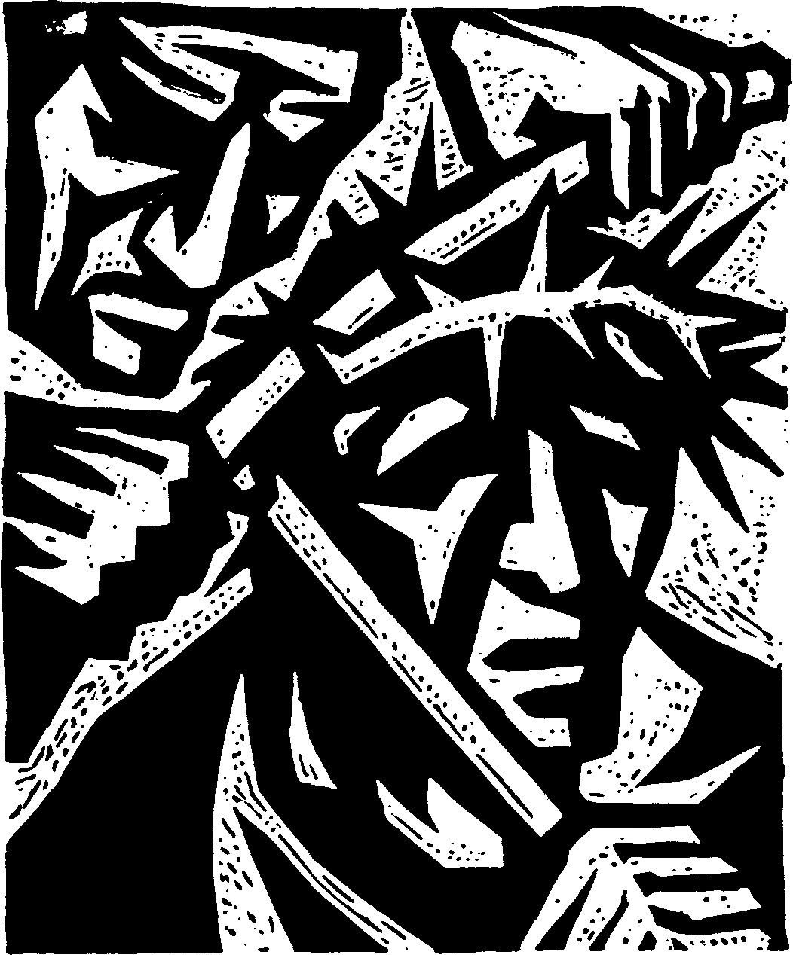
19
II
OUR PROOFS OF THE CRUCIFIXION
OF CHRIST
There are a great many and it is not within the scope
of this booklet to mention them all in detail. The
following are a few:
1. THE PROPHECIES
There are many prophecies in the Bible pointing to
the atoning death of Christ on the cross, all of which
were literally fulfilled.
Prophecy - the selling of Christ for thirty pieces of
silver.
Zechariah 11:12. "Then I said to them, 'If it seems
right to you, give me my wages, but if not, keep them'.
And they weighed out as my wages thirty shekels of
silver."
Fulfilment. Matthew 26:14. "Then one of the twelve,
who was called Judas Iscariot, went to the chief priests
and said, 'What will you give me if I deliver Him to
you?' And they paid him thirty pieces of silver."
20
Prophecy - The buying of the Potter's field with the
money.
Zechariah 11:13. "Then the Lord said to me, 'Cast it
into the treasury', the lordly price at which I was paid
off by them. So I took the thirty shekels and cast them
into the treasury in the house of the Lord."
Fulfilment. Matthew 27:3 to 8. "When Judas, His
betrayer, saw that He was condemned, he repented
and brought back the thirty pieces of silver to the chief
priests and the elders, saying, 'I have sinned in
betraying innocent blood'. They said, 'What is that to
us? See to it yourself. And throwing down the pieces
of silver in the Temple he departed and went and
hanged himself. But the chief priests, taking the pieces
of silver, said, 'It is not lawful to put them into the
treasury since they are blood money'. So they took
council and bought with them the potter's field to
bury strangers in. Therefore the field has been called
the Field of Blood to this day."
Prophecy - the mocking and crucifixion.
Psalm 22:16 to 18. "Dogs are round about me;
a company of evil doers encircle me; they have
pierced my hands and feet; I can count all my bones;
they stare and gloat over me; they divide my
garments among them, and for my raiment they cast
lots."
21
Fulfilment. Mark 15:16 to 20. "The soldiers led Him
away inside the palace, and they called together the
whole battalion. And they clothed Him in a purple
cloak and plaited a crown of thorns and put it on Him.
And they began to salute Him 'Hail, King of the
Jews'. They struck His head with a reed, and spat
upon Him, and they knelt down in homage to Him.
And when they had mocked Him and stripped Him of
the purple cloak, they put His own clothes on Him
and led Him out to crucify Him."
Prophecy - wounded and beaten.
Isaiah 53:5. "He was wounded for our trans-
gressions; He was bruised for our iniquities; upon
Him was the chastisement that made us whole, and
with His stripes we are healed." Zechariah 12:10. "I
will pour out on the house of David and the inhabi-
tants of Jerusalem a spirit of compassion and suppli-
cation, so that when they look on him, whom they
have pierced, they shall mourn for him, and weep
bitterly over him."
Fulfilment. Luke 22:63 to 65. "The men who were
holding Jesus, mocked Him and beat Him. They also
blindfolded Him and asked Him 'Prophesy! who is it
that struck you?' And they spoke many other words
against Him, reviling Him." John 19:34. "One of the
soldiers pierced His side with a spear, and at once
there came out blood and water."
22
Prophecy - He accepts His ordeal in silence.
Isaiah 53:7. "He was oppressed and he was
afflicted, yet he opened not his mouth; like a lamb that
is led to the slaughter, and like a sheep before its
shearers is dumb, so he opened not his mouth."
Fulfilment. 1 Peter 2:23 and 24. "He committed no
sin; no guile was found on His lips. When He was
reviled, He did not revile in return. When He suffered
He did not threaten, but trusted to Him Who judges
justly. He himself bore our sins in His body on the
tree, that we might die to sin and live to righteousness.
By His wounds you have been healed."
Prophecy - He was beaten and spat upon.
Isaiah 50:6. "I gave my back to the smiters, and my
cheeks to those who pulled out the beard. I hid not my
face from shame and spitting."
Fulfilment. Mark 15:19. "They struck His head with
a reed and spat upon Him, and knelt down in homage
to Him."
Prophecy - they mock Him.
Psalm 22:6 and 7. "I am a worm and no man;
scorned by men and despised by the people. All who
see me mock at me. They make mouths at me, they
wag their heads."
23
Fulfilment. Matthew 27:39 to 42. "Those who
passed by derided Him, wagging their heads and
saying, 'You who would destroy the Temple and build
it in three days, save yourself! If you are the Son of
God come down from the cross'. So also the chief
priests, with the scribes and elders, mocked Him
saying, 'He saved others, He cannot save Himself. He
is the King of Israel, let Him come down now from the
cross and we will believe Him'."
Prophecy - His astonishment that the Father forsook
Him.
Psalm 22:1. "My God, my God, why hast thou
forsaken me? Why art thou so far from helping me,
from the words of my groaning?"
Fulfilment. Matthew 27:46. "About the ninth hour,
Jesus cried with a loud voice, 'Eli, Eli, lama
sabachthani?' That is, 'My God, My God, why hast
Thou forsaken Me?'"
Prophecy - they gave Him vinegar to drink.
Psalm 69:21. "For my thirst they gave me vinegar to
drink."
Fulfilment. John 19:28. "After this, Jesus knowing
that all was now finished said, to fulfil the Scripture, 'I
thirst' ... so they put a sponge full of the vinegar on
hyssop and held it to his mouth."
24
Prophecy - soldiers divided His clothes by lot.
Psalm 22:18. "They divided my garments among
them and for my raiment they cast lots."
Fulfilment. John 19:23. "When the soldiers had
crucified Jesus they took His garments and made four
parts, one for each soldier, also His tunic."
Prophecy - His bones were not broken.
Psalm 34:20. "He keeps all his bones; not one of
them is broken."
Fulfilment. John 19:32 and 33. "The soldiers came
and broke the legs of the first and of the other who had
been crucified with Him, but when they came to Jesus
and saw that He was already dead, they did not break
His legs."
Prophecy - pierced by a spear.
Zechariah 12:10. "When they look on him whom
they have pierced, they shall mourn for him."
Fulfilment. John 19:34. "One of the soldiers pierced
His side, with a spear, and at once there came out
blood and water."
25
Prophecy - His death with the wicked, but honoured
also.
Isaiah 53:9. "They made His grave with the wicked,
and with a rich man in his death."
Fulfilment. Matthew 27:57 to 60. "When it was
evening, there came a rich man, from Arimathea,
named Joseph, who also was a disciple of Jesus. He
went to Pilate and asked for the body of Jesus. Then
Pilate ordered it to be given to him. And Joseph took
the body, and wrapped it in a clean linen shroud, and
laid it in his own tomb, and rolled a great stone to the
door of the tomb and departed."
2. THE STATEMENTS OF CHRIST
Many times Christ explained to His disciples that
His work of salvation necessitated His death on the
cross. The most outstanding occasion comes in His
farewell message, which He spoke to them on the
night of His betrayal. In it He went again over the
wonder of the Gospel. The following are some of His
special pronouncements about His death on the cross
to redeem humanity.
Matthew 16:21. "From that time Jesus began to
show His disciples that He must go to Jerusalem and
suffer many things, from the elders and chief priests
and scribes, and be killed and on the third day be
raised."
26
Matthew 17:22. "As they were gathering in Galilee,
Jesus said to them, 'The Son of Man is to be delivered
unto the hands of men, and they will kill Him, and He
will be raised on the third day'. And they were greatly
distressed."
Matthew 26:1 and 2. "When Jesus had finished all
these sayings, He said to His disciples, 'You know that
after two days the Passover is coming, and the Son of
Man will be delivered up to be crucified."
Mark 8:31. "He began to teach them that the Son of
Man must suffer many things, and be rejected by the
elders and chief priests and the scribes, and be killed,
and after three days rise again."
Mark 9:31. "For He was teaching His disciples and
saying to them, 'The Son of Man will be delivered into
the hands of men, and they will kill Him, and when He
is killed, after three days He will rise.'"
Mark 10:32 to 34. "And they were on the road going
up to Jerusalem, and Jesus was walking ahead of
them, and they were amazed and those who followed
were afraid. And taking the twelve again He began to
tell them what was to happen to Him, saying, 'Behold,
we are going up to Jerusalem, and the Son of Man will
be delivered to the chief priests and scribes, and they
will condemn Him to death, and deliver Him to the
Gentiles, and they will mock Him and spit upon Him
27
and scourge Him and kill Him; and after three days
He will rise'."
Luke 9:22. "The Son of Man must suffer many
things, and be rejected by the elders and chief priests
and scribes and be killed, and on the third day be
raised."
John 3:13 and 14. "No one has ascended into
heaven but He who descended from heaven, the Son
of Man. And as Moses lifted up the serpent in the
wilderness so must the Son of Man be lifted up, that
whoever believes in Him may have eternal life."
3. THE TESTIMONY OF THE APOSTLES
All who read the Acts of the Apostles and their
Epistles notice that the doctrines which they preached
and spread abroad in all the world were based on the
message of Christ crucified for the sins of the world.
What follows is a gleaning from the words of the
apostles who, after preaching this message, wrote it,
guided by the Holy Spirit, for our instruction. Acts
2:22 and 23, "Men of Israel hear these words. Jesus of
Nazareth, a man attested to you by God, with mighty
works and wonders and signs, which God did through
Him in your midst, as you yourselved know - this
Jesus delivered up according to the Will and Plan and
the Foreknowledge of God, you crucified and killed
by the hands of lawless men. But God raised Him
up...."
28
Paul said in 1 Corinthians 2:7 and 8, "We impart a
secret and hidden wisdom of God, which God decreed
before the ages for our glorification. None of the
rulers of this age understood this, for if they had they
would not have crucified the Lord of Glory."
John the Apostle said in 1 John 1:7, "If we walk in
the light, as He is in the light, we have fellowship with
one another, and the blood of Jesus, His Son, cleanses
us from all sin."
Read also Acts 2:36; Romans 6:5 and 6; 1 Corin-
thians 1:17 and 18; 1 Corinthians 1:22 to 24; 1 Corin-
thians 2:1 and 2; 2 Corinthians 13:3 and 4; Galatians
3:13; Philippians 2:5 to 8; and Hebrews 12:2.
4. THE SIGNS WHICH ACCOMPANIED THE
DEATH OF CHRIST
Matthew, the writer of the Gospel, tells us that
when Jesus yielded up His Spirit, the sun was
darkened, and the veil of the temple was torn in two
from top to bottom, the earth shook and the graves
were opened. Matthew 27:50 to 54; "And Jesus cried
again with a loud voice and yielded up His spirit. And
behold, the curtain of the Temple was torn in two,
from top to bottom, and the earth shook, and the
rocks were split; the tombs also were opened and
many bodies of the saints who had fallen asleep were
raised, and coming out of the tombs after His resur-
29
rection, they went into the holy city and appeared to
many. When the centurion, and those who were with
him, keeping watch over Jesus, saw the earthquake
and what took place, they were filled with awe and
said, 'Truly this was the Son of God'."
There were outward signs in nature, the elements
were moved and because of them men's spirits were
stirred, so that the Roman Centurion, a heathen,
responsible for carrying out the death sentence on
Christ, and others with him, were astonished and
believed in the One crucified, saying "Of a truth, this
was the Son of God". This unique phenomenon had
not been seen, neither before nor after any man's
death.
5. THE RESURRECTION OF CHRIST.
This wonderful event was fulfilled in keeping with
the word of Christ to the Pharisees and the scribes,
"Destroy this temple, and I will raise it up the third
day". Indeed, at dawn on the third day, the first day of
the week, there happened the greatest miracle of all
time. The Lord of glory rose from among the dead.
Heaven itself proclaimed this wonderful event. Before
dawn came a great earthquake, as God's angel des-
cended from heaven and rolled away the huge stone
from the door of the tomb. His appearance was as
lightning, and the guards, charged by Pilate to
safeguard the tomb, shook with terror. This watch
was put because the chief priests had circulated the
30
story that Jesus' disciples planned to steal His body,
or hide it away saying that He had risen.
On that glorious morning a group of women came
to the tomb bringing with them spices to anoint the
body of Jesus as a last respect. The first to arrive was
Mary Magdalene and Mary the mother of James.
When they found the stone rolled away from the door
of the tomb, and the tomb empty, they were
astonished. While they were questioning, an angel of
God appeared and told them not to be afraid.
Matthew 28:1 to 7, "Now after the sabbath, toward
the dawn of the first day of the week, Mary
Magdalene and the other Mary, went to see the
spulchre. And behold, there was a great earthquake,
and a angel of the Lord descended from heaven, and
came and rolled back the stone, and sat upon it. His
appearance was like lightning, and his raiment white
as snow. And for fear of him, the guards trembled,
and became as dead men. But the angel said to the
women, 'Do not be afraid, for I know that you seek
Jesus who was crucified. He is not here, for He has
risen, as He said. Come - see the place where He lay.
Then go quickly and tell His disciples that He has
risen from the dead; and behold He is going before
you to Galiliee, there you will see Him. Lo, I have
told you'."
And Matthew 28:9 and 10 say, "And toehold Jesus
met them, and said 'Hail'. And they came up and
took hold of His feet and worshipped Him. Then
31
Jesus said to them, 'Do not be afraid; go and tell My
brethren to go to Galilee, and there they will see me'."
This is what happened at the resurrection. It was
written in the Gospel by the inspiration of God and
no one who believes the Word of God dare deny it. If
they do so, it is as if they allege that God and all the
angels and Christ were in agreement to deceive
people.
6. THE TESTIMONY OF HISTORY
The death of Christ on the Cross is confirmed by
the early historians, heathen and Jewish. They have
written about it very clearly.
- Tacitus, the historian, a heathen, in the year 55
A.D. wrote in his huge volume detailed passages
about the crucifixion of Christ and His sufferings.
- Josephus, the Jew, born a few years after the
crucifixion, wrote the history of his people in twenty
volumes, and gave in his writings a detailed account
of the crucifixion of Christ, as ordered by Pilate.
- Lucien, the Greek, (100 A.D.) an outstanding
Greek historian, wrote of the death of Christ and
about the Christians. As he was an Epicurean by
belief, he could not understand the faith of Christians
and their readiness to die for Christ. In his writings he
ridiculed their belief in the immortality of the soul
32
and their longing for heaven. He looked on them as a
deceived people, clinging to uncertainties after death
rather than living for the present. One of the signi-
ficant allusions to the subject of Christ in his writings
in this, "The Christians continue to worship that
great man who was crucified in Palestine because he
brought a new religion to the world".
7. THE TESTIMONY OF PILATE, THE ROMAN
GOVERNOR.
This tyrant sent to Tiberius Caesar a full report of
the crucifixion of Christ, His burial, His rising from
the dead and this report is among Roman records. It
was one of the documents with which the Christian
scholar Tertullian supported his famous defence of
the Christians.
8. THE SYMBOL OF THE CROSS
This is a material proof no one can deny, for every
religion has its distinguishing emblem, such as the
sixpointed star of the Jews and the crescent of the
Muslims. The sign of the cross was known from the
earliest era of Christianity. The early Christians
carved it on the graves of the dead and in the
catacombs where they used to meet in times of
persecution.
33
9. THE TESTIMONY OF TIME AND
CHRISTIAN CONTINUANCE.
The ordinance of the Lord's Supper, which
reminded them of the death of Christ on the cross, is a
living testimony throughout the passing ages that
Christ died by crucifixion. Certainly this rite, which
Christ instituted on the night He was betrayed, and
which He commanded His disciples to observe, is a
continual reminder of His atoning death and a strong
proof which is impossible to contradict. The apostles
kept this divine precept and committed it to the
church from the beginning, as Paul said in 1
Corinthians 11:23 to 26, "For I received from the
Lord that which I also delivered to you, that the Lord
Jesus, on the night He was betrayed, took bread, and
when He had given thanks, He broke it and said 'This
is My body, which is for you. Do this in remembrance
of Me'. In the same way, the cup after supper saying
'This cup is the new covenant in My blood. Do this as
often as you drink it in remembrance of Me! For as
often as you eat this bread, and drink this cup, you
proclaim the Lord's death until He comes.'"
10. THE TESTIMONY OF THE JEWISH
TALMUD.
It is well known that the Talmud is a holy book in
Jewish eyes. It has been collected in huge volumes,
which anyone interested can see. In the copy
published in 1943 in Amsterdam one can read, on
34
page 42, this sentence, "Jesus was crucified one day
before the Passover. We warned Him for 40 days that
He would be killed because He was a magician and
planned to deceive Israel with His delusions.
Whoever wished to do so was asked to defend Him,
and when none did, He was crucified on the eve of the
Passover. Does anyone dare to defend Him? Was He
not a stirrer up of evil? It is said in the prophets,
Deuteronomy 13:8, 'To a person such as this, do not
listen, nor shall your eye pity him, nor shall you
conceal him, but you shall kill him.'"
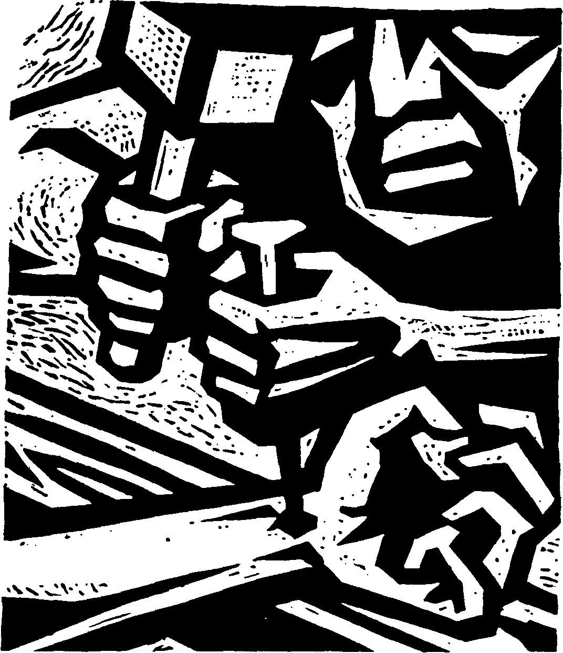
35
Ill
WHY WAS CHRIST CRUCIFIED?
We often hear this question asked, especially in
these days. There is a clear answer to it in the Christian
creed of faith - "It was for us humans and for our
salvation He came down from heaven and was born of
the Holy Spirit by the Virgin Mary. He became a man
and was crucified for us in the days of Pontius Pilate.
He suffered and was buried and rose again on the
third day and ascended into heaven".
The following are some proofs of the necessity for
Christ's atoning death on the Cross:
1. The Need of Salvation.
There is no doubt that all men are in need of salva-
tion, because sin is found in every human heart.
Romans 3:23 says, "For all have sinned and come short
of the glory of God". Isaiah, the prophet, in chapter 53
and verse 6, said, "All we like sheep have gone astray;
we have turned everyone to his own way, and the Lord
has laid on him the iniquity of us all". John, in his first
letter, chapter 1, and verses 8 to 10, said, "If we say we
have no sin we deceive ourselves, and the truth is not in
us. If we confess our sins, He is faithful and just, and
will forgive our sins, and will cleanse us from all
unrighteousness. If we say we have not sinned we make
Him a liar, and His word is not in us".
36
In the heart of every man there is the awareness
that repentance alone cannot remove past sins. There
must be a more effective means of obtaining
forgiveness; this means that there must be
"atonement". Otherwise how can we explain the
existence of sacrifices from the beginning of time, and
the widespread knowledge of sacrifice among most of
the religions of the world.
Is it not because this concept meets the sense of
need in the heart of the sinner for atonement for his
sin?
2. The Proof of Reason.
All read and know that God is holy and that man is
sinful, and sin is an insult to the name of God and
destructive to man whom God created in His likeness.
Thus he now deserves the judgement of God. God
cannot be just unless He punishes the sinner. Repen-
tance, which is but a return to the place of obedience,
cannot bring the justification sought. There is nothing
of atonement in it; that is atonement for past sins. The
honour and justice and holiness of God cannot be
satisfied by mere repentance.
3. Atonement Meets the Demands of Law.
Divine law cannot renounce its right to judge, for it
says "the wages of sin is death". It demands the
punishment of the offender. A law which lets the
37
offender off is not as just law. The law is the "public
prosecutor" and the public prosecutor cannot
relinquish the demand of law that the offender be
punished; or he would be discredited as not being an
honest upholder of divine justice. In short, the law,
divine law, demands punishment of the offender, or
atonement for his sins. Here our hearts must be filled
with praise and thanks that Christ offered this
atonement for man; that, as a result, everyone who
accepts Him as Saviour obtains, in His Name,
forgiveness of sin. The blessing for all humanity is that
this atonement of Christ was inclusive and no one can
say that Christ did not die for him. How wonderful
are the words of Isaiah 53:12, "Therefore I will divide
him a portion with the great... because he poured out
his soul to death, and was numbered with the
transgressors; yet be bore the sin of many, and made
intercession for the transgressors". Paul said in
Hebrews 5:8 and 9, "Although He was a Son, He
learned obedience by what He suffered, and being
made perfect He became the source of eternal
salvation to all who obey Him".
4. Atonement Meets Man's Moral Need
It is true that every man has a moral nature and a
conscience able to appreciate heights of justice and
holiness. If he is dissatisfied with his sin, and finds no
atonement, he is troubled in spirit and his moral sense
is distrurbed.
38
It is agreed that man, in spite of his downfall into a
practice of sin, has not had his conscience destroyed.
This moral power remains which can discern right
from wrong and decides as to punishment or reward.
We can say that this power is an echo of the voice of
God who created it, and absolutely fitted it to respond
to His laws given on Mount Sinai. But this power,
conscience, important as it is, cannot save a man from
judgement.
It can influence man's leanings towards sin, but it
cannot justify him. It believes the law is good, but the
law also cannot justify. The law, Paul said, leads us to
Christ.
So the voice of conscience, or the sense of sin,
demands for us a righteous mediator, who atones for
our sins; but with all the importance of this truth most
people attempt to solve the problem of conscience by
doing works of self-righteousness, reckoning that
good works are comparable to the mercy of God.
5. God's Plan for Atonement.
If there had been no reason for atonement, God
would not have planned it. Jesus said in Matthew
20:28, "The Son of Man came not to be served but to
serve, and to give His life a ransom for many". Also in
John 3:16, Jesus said, "For God so loved the world,
39
that He gave His only Son, that whoever believes in
Him should not perish, but have eternal life".
In Galatians 4:4, Paul said, "But when the time had
fully come, God sent forth His Son, born of woman,
born under the law".
These glorious verses show us that God loved man
with a wonderful love, rich in mercy. This love,
overflowing with mercy, was incarnate in Jesus, who
gave expression to it by redemption which He
completed on the cross, that all may know that God is
not only holy and just, but also is love. Redemption
awakens the sinner's conscience through love, and
love is the bond which links him to the cross,
without which God could not prove His love. So Jesus
said, "I, if I be lifted up, will draw all men unto
me".
My dear reader, we live in a time full of voices.
"Behold the new order and act accordingly." "Here is
a new brotherhood. Accept it." "We extend a helping
hand." But empty is the voice which leaves out the
cross of Christ. Without the cross all "new orders"
fail, and the "new brotherhood" is a lie and the
"helping hand" turns into a hand brandishing
weapons.
The mistake of our generation is like that of the
Greeks and ancient Jews, in their thoughts about the
40
cross, looking on it as foolishness and weakness and
insignificant and a stumbling block. In their mistaken
estimation they have forgotten to raise the cry for
help, or to say. "Behold the Lamb of God who takes
away the sin of the world." They have forgotten the
word of wisdom which says in Proverbs 14:34,
"Righteousness exalts a nation, but sin is a reproach
to any people".
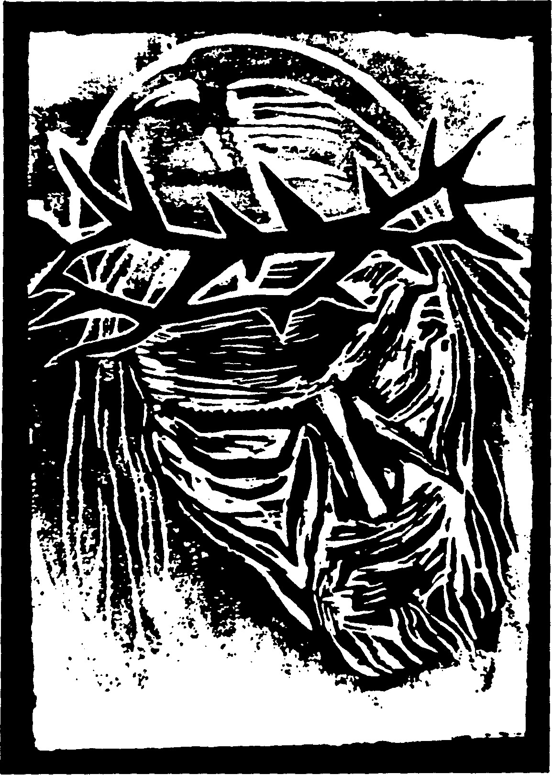
41
Quiz:
THE CROSS
in the Gospel and the Koran
Dear Friend, After reading this booklet you may
answer the following questions carefully. If 15 of your
answers are right we will send you another booklet out
of the series, "Comparisons between the Gospel and
the Koran". When you have finished 9 booklets we will
send you a certificate entitled, "Knowledge in the
Gospel and the Koran (in its main differences)".
Questions:
- Muslims have two ideas about the death of Christ.
Which one do you consider more possible?
- Where should a researcher begin to look for the
full truth about the end of Christ's life on earth,
besides the Koran?
- How did Paul, the Apostle, summarize the gospel
in his first letter to the Corinthians 15:1-4.
- Summarize the heretical error which was spread
among the Christians on the Arabic Penninsula.
- Where did Islam inherit the aversion to the cross?
- Comment on the story of the "likeness" that
Christ only APPEARED to be crucified.
- What is your opinion of Al-Razi's theory in the
story of the "likeness" of Christ's crucifixion.
- Write one of the verses in the Koran which
mentions the death of Christ.
9. Where in the Koran is it written that the Jews said,
"Really, we have killed the Christ"?
- Write one of the prophecies about the crucifixion
of Christ and the corresponding verse of its fulfill-
ment in the gospel.
- Which prophecy - and its fulfillment - impressed
you the most?
- What can you conclude from the revelations
Christ made in advance about his own crucifixion
and death?
- What is the main subject in the testimony of the
apostles and their message about Christ?
- What actually happened when Christ gave up his
spirit on the cross?
- Do you believe in the resurrection of the dead and
what is your opinion of the resurrection of Christ?
- Write one of the historical testimonies about the
death of Christ and his resurrection.
- What is the main theme of Christianity and since
when has it existed?
- What is the innermost aim of the Lord's Supper?
- Is there any indication of Christ's crucifixion in the
Jewish Talmud?
- In your opinion, why was Christ crucified?
- Write down John 3:16 and memorize it!
Please don't forget to write your full name and address
at the end of your test. DO NOT write other remarks
on your test paper, but on a seperate sheet. We are
waiting for your answer.
THE GOOD WAY RO.BOX 66
CH-8486 RIKON (SUISSE)
THE GOOD WAY

CH-8486 RIKON/RO.BOX 66
SWITZERLAND
BOOKSAND CASSETTES
FOR MUSLIMS

The following evangelistic books and cassettes were especially prepared
for Muslims. A number of them are available in different languages.
Key for languages:
A = Arabic/B = Bengali/E = English/
M = Malayalam/R = Russian/T = Turkish/U = Urdu/
When ordering, please specify for every title the language
you require. Thank you.

COMPARISONS BETWEEN Price
THE GOSPEL AND THE KORAN Pages SFr.
A.) GOD, CHRIST AND THE TRINITY
GOD IS ONE —
IN THE HOLY TRINITY
B. Zachariah 82 3.-

DID GOD APPEAR IN
THE FLESH?
72
48
24
64
Abd al-Masih
THE LIGHT OFTHE WORLD George Ford
HOW CAN WE KNOW THE
TRUTH OF THE GOSPEL? Isk. Jadeed
THE PERSON OF CHRIST
IN THE GOSPEL AND
THE KORAN
GOD AND CHRIST
WHAT DO YOU THINK
ABOUT CHRIST?
Isk. Jadeed
Isk. Jadeed
Isk. Jadeed
48 2.—
3.—
2.—
1.—
2,—
24 1.—

B.) SALVATION
48 2.—
2.—
2.—
48
40
SIN AND ATONEMENT
Isk. Jadeed 48 2.—
HOW CAN YOU BE SAVED,
OMAN?
(Part 2 of Mizaan ul Haqq)
CG. Pfander 136 4.-
THE CROSS
IN THE GOSPEL AND
THE KORAN Isk. Jadeed
GOD'S SALVATION IS
READY FOR YOU Abd al-Masih
HOW DO WE PRAY? Isk. Jadeed

Pnce
Pages SFr.
■s
I
(d

C.) THE UNCHANGED BIBLE
NO DISTORTION IN
THE TORAH AND THE GOSPEL
(Part 1 of Mizaan ul Haqq) C. G. Pfander 136 4.—
THE INFALLIBILITY OF
THE TORAH AND
THE GOSPEL Isk. Jadeed 64 2.-

THE GOSPEL OF BARNABAS
IS A FALSE TESTIMONY Isk. Jadeed
24 1.—

NO, THE RELIGION OF
CHRIST IS NOT
ABROGATED
D.) GENERAL SUBJECTS
RESEARCH FOR THE
DILIGENT
VICTORY OF
THE TRUTH
TEACH ME YOUR WAY,
O LORD!
Isk. Jadeed 24 1.—
N. Ghabriel 112 4.—
Isk. Jadeed
Isk. Jadeed
112 4.—
32 1.50

TEST EVERYTHING, HOLD
ON TO THE GOOD! Isk. Jadeed
88
CHRISTIANITY IN ISLAM IbrahimLuka 208
3.—
5.—

BALANCE OF TRUTH
(combined vol. of part 1 and 2)
(combined vol. of part 1, 2 and 3)
TRACTS
(based on the above mentioned
comparison booklets)
CG.Pfander 300 7.—
1000
tracts 40.—

BIOGRAPHIES ^_{gcs} ££ | ! | Bengali | English | Malayal. | | Russian | ■s  ?
FOR THE SAKE OF TRUTH Isk. Jadeed 264 6-  (under print)  TEN MUSLIMS  MEET CHRIST Miller 324 8-  IN SEARCH OF ASSURANCE A. A'. Alavi 56 2-  SWEET FIRSTFRUITS (A+U) 184 5- | XXX X |  | X  X | X |  |  | X

TESTIMONIES OF ARAB YOUTH:
MOROCCO PRAISES THE LORD 48 2-  THE RIGHTEOUS SHALL GROW  LIKE A CEDAR IN LEBANON 32 ISO  SUDAN HURRIES TO GOD 32 1.50  THE YOUTH OF IRAQ SURRENDERS  TO THE LORD 48 2-  TRACTS testimonies 1000  tracts 40.— | X XX X X | X | X | X

MAGAZINE: „THE MEETING POINT'
SECRETS OF WISDOM 40 2-  THE WINGS OF PEACE 32 2- | X  X

CASSETTES (in Arabic only, other wise specified) ...

THE NEW TESTAMENT ON CASSETTE
THE GOSPEL OF MATTHEW: 1:1-9:38
60  60  60  40 | 9.  9.  9.  6.
90  40 | 12.  6.
90  90  40 | 12.  12.  6.
40 | 6.
60 | 9.
40 | VO*
40 | 6.
60 | ON*
60 | 9,
40 | 6,
60 | On
90 | 12,
90 | 12,
10:1 -17:27
18:1 -25:30
25:31-28:20
THE GOSPEL OF MARK: 1:1 -12:27
12:28-16:20
THE GOSPEL OF LUKE: 1:1 - 9:62
(This Gospel is also available 10:1 -21:38
in English on two 60 min. cass.) 22:1 -24:35
PRAISE THE LORD
(Hymns of praise and thanks with Bible verses)
THE BETTER LIFE
(The way that leads to God, with modern hymns)
PREPARE THE WAY OF THE LORD
(Matthew 1—4 with selected hymns)
HAVE MERCY ON ME, O GOD
(Selected hymns with Bible verses)
GOD'S PROMISES IN CHRIST
(God's promises in the Old Testament and
their fulfillment in the New Testament, with
selected hymns)
THE GREATEST BIRTH
(The story of Christ's birth according
to Luke, with Christmas hymns)
THE CONSTITUTION OF THE
KINGDOM OF GOD
(Matthew 5—7 with selected hymns)
WHAT DO YOU THINK ABOUT CHRIST?
(Meditations on the life of Christ with selected hymns) (A+ E)
THE GREAT SACRIFICE AND
THE CONQUEROR OF DEATH
(Christ's crucifixion and resurrection according
to Matt. 26-28)
GOD'S SALVATION IS READY FOR YOU
(A call to faith and new life, with selected hymns) (A+E)
THIS IS THE DAY OF SALVATION
(Selected hymns with Bible verses) 40 6.
CHRIST - THE RESURRECTION AND LIFE
(Selected passages from the Bible for comfort
in times of mourning) 4U "•
JESUS, YOU ARE MY GREAT TREASgRE
(Selected hymns with Bible verses) 60 9.
YOU ARE THE LIGHT OF THE WORLD
(Selected hymns with Bible verses) 60 9.
MY GRACE IS SUFFICIENT FOR YOU
(Selected hymns with Bible verses) 60 9.
COME, O LORD JESUS!
(Selected hymns with Bible verses) 60 9.
JESUS IS THE ANSWER
(Selected hymns with Bible verses) (English only) 40 6.
ALL TO JESUS I SURRENDER
(Selected hymns with Bible verses) (English only) 60 9.
Books in Urdu should be demanded from:
NIDA-E-UMEED, POST BOX NO. 8617
DELHI-110054, INDIA
Bdoks in Malayalam may be obtained from:
MARKAZ-UL-BISHARA, P.O.BOX 18
MANJERI 676121, KERALA, INDIA
Books in Bengali can be ordered from:
MASIHEE JAM AT, G. P. O. BOX 3507
DHAKA, BANGLADESH
Books in Russian are printed by:
LIGHT IN THE EAST, Postfach 1340
7015 Korntal, W. Germany
In Canada and USA you can find most of our books in English and Arabic in
the following centers:
F.EM., 205 YONGE STREET, ROOM 25
TORONTO, ONTARIO, CANADA M5B 1N2
VOICE OF THE TRUTH, P.O.BOX 15013
COLORADO SPRINGS, CO. 80935, USA


